**URBAN AGENDA FOR THE EU**

Partnership on Innovative and Responsible Public Procurement

Final Draft ACTION PLAN

10th June 2018

*** The Pact of Amsterdam states that the Action Plan "can be regarded as non-binding". Therefore, the actions presented in this Action Plan are not compulsory. ***

1 INTRODUCTION 4

1.1. Urban Agenda for the EU 4

1.2. The Partnership 4

1.2.1. Presentation of the Partnership and composition 5

1.2.2. Objectives 6

1.2.3. Working method 7

2 ACTIONS 8

2.1 Theme 2.1 Building procurement strategy and managing strategic procurement 10

* 2.1.1 Action 2.1.1 Guidance on building city strategic procurement and how to manage strategic procurement 10
* 2.1.2 Action 2.1.2 Measuring spend and wider impact in European Cities 14
* 2.1.3 Action 2.1.3 Recommendation(s) for seeking future EU funding for joint cross-border procurement, procurement of innovation, strategic procurement in particular social procurement and circular procurement 16

2.2 Theme 2.2 Developing relationships with economic operators; utilising the market potential and bringing it closer to the purchasers 19

* 2.2.1 Action 2.2.1 Innovation procurement brokerage 19

2.3 Theme 2.3 Providing guidance on legal tools and improving competence on innovative and sustainable procurement 24

* 2.3.1 Action 2.3.1 Legal Handbook Innovative Public Procurement 24
* 2.3.2 Action 2.3.2 Develop a flexible and customisable concept for Local Competence Centres for innovative and sustainable procurement. 27
* 2.3.3 Action 2.3.3 Competence building in Circular Procurement 32

3 RECOMMENDATIONS 35

4 LINKS WITH OTHER COMMITMENTS 36

4.1 Link with the cross-cutting issues 36

4.2 New Urban Agenda & Sustainable Development Goals 39

5 TO CONCLUDE 40

6 MONITORING 41

ANNEX: EXISTING INITIATIVES AND PROJECTS 42

# 1 INTRODUCTION

## Urban Agenda for the EU

The ‘Pact of Amsterdam’ of May 2016 has established the Urban Agenda for the EU: a new working method of thematic Partnerships seeking to optimise the utilisation of the growth potential of cities and to address social challenges. It aims to do so through better cooperation between cities, regions, Member States, the European Commission and other stakeholders. Following the 12 priority themes outlined in the Urban Agenda for the EU, 12 thematic Partnerships have been established so far. The Partnership on Innovative and Responsible Public Procurement is one of these Partnerships, and was formally established in May 2017.

**Figure 1: Overview of the 12 Priority Themes of the Urban Agenda and their connections**

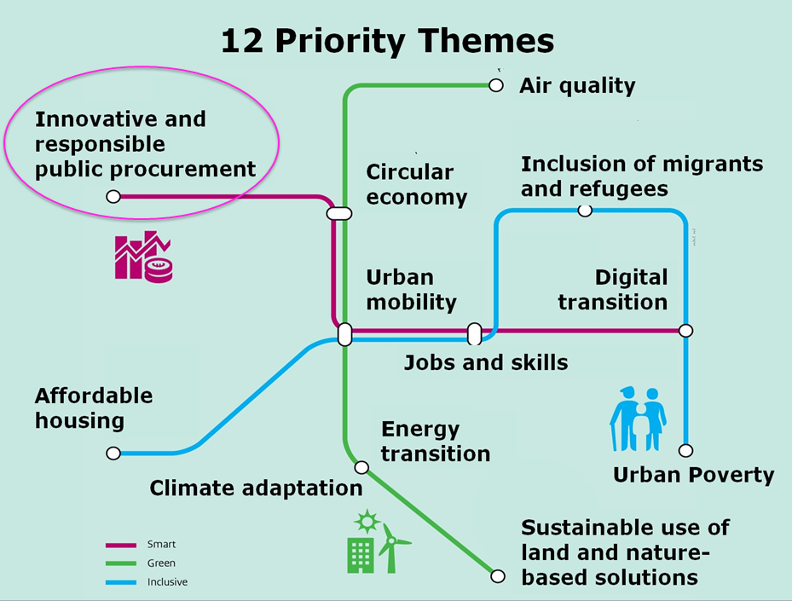

The Urban Agenda for the EU focuses specifically on three pillars of EU policy making and implementation: better regulation, better funding and better knowledge.

## The Partnership

Cities are responsible for providing public services to ensure a better quality of life for their citizens. When doing so, cities operate in a rapidly changing social and environmental context. This context creates challenges as well as opportunities. There are various ways for cities to deliver these public services. They can decide to perform these services themselves, they can subsidise them, or they can provide the services by tendering out contracts. Once decided to provide public services by tendering out a contract, one enters the realm of this Partnership: innovative and responsible public procurement.

This Partnership creates the opportunity for cities and Member States to work closely together with the European institutions to research and assess how to facilitate more use of innovative and responsible public procurement.

The Partnership on Innovative and Responsible Public Procurement seeks to facilitate a joint effort for a public procurement strategy of cities that facilitates and supports innovation and sustainability (social, economic and environmental). The focus of the Partnership is on the mid- and long-term perspective of public procurement. Thereto, the Partnership has established three topics that need to be addressed:

* building procurement strategy and managing strategic procurement;
* developing relationships with economic operators; utilising the market potential and bringing it closer to the purchasers;
* providing guidance on legal tools and improving competence on innovative and sustainable procurement.

## Presentation of the Partnership and composition

The members of the Partnership are:

* Member States: Italy;
* Cities: Haarlem (co-ordinator), Vantaa, Preston, Nantes, Gabrovo, Munich, Turin, Larvik;
* Stakeholders: CEEP, ICLEI;
* European Commission: DG REGIO, DG GROW, DG CONNECT;
* Observers and associations: CEMR, Eurocities, UIA, URBACT, KEINO.

**Figure 2: Governance arrangements of the Partnership**

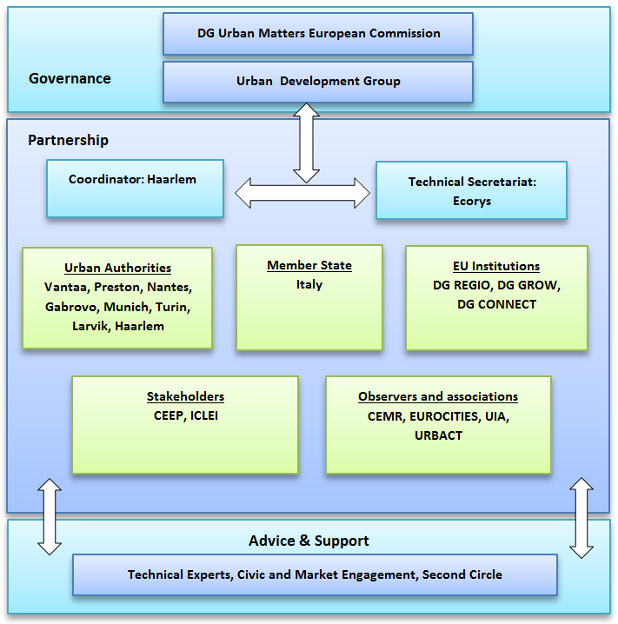

## Objectives

**“Every year, over 250 000 public authorities in the EU spend around 14% of GDP on the purchase of services, works and supplies. In many sectors such as energy, transport, waste management, social protection and the provision of health or education services, public authorities are the principal buyers.” [1]**

Today, procurement is becoming more strategic, more collaborative, and more technology-dependent than ever. Innovative and responsible public procurement empowers public authorities to obtain pioneering, innovative solutions customised to their specific needs. It helps local and central governments to provide taxpayers with the best possible quality services, while at the same time saving costs. It helps to create jobs and boost the competitiveness of European industry and small and medium-sized enterprises (SMEs). It also encourages more efficient, sustainable and innovative public services. Public procurement can thus become an important instrument for proactively pursuing EU 2020 policy objectives.

Public buyers in Europe have a significant role to play in societal transformation, and cities are important public buyers. For public authorities to act as lead customers, they must define long term needs, develop an innovation policy and a procurement strategy. This means that not only there has to be a focus on the procurement process (“how”), but also a focus on the issues to be solved (“what”).

**The aim of this Partnership is to push forward the development and implementation of an ambitious procurement strategy as an integrated and supportive management tool for governance.** Using public procurement and the procurement of innovation as a strategic management tool, cities can significantly increase the positive impact on their social, economic and environmental objectives. When procurement strategies are well aligned in an overall management strategy, procurement has the potential to contribute as a catalyst at all levels of the multi-level governance in the EU Urban Agenda. Thus the Partnership contributes to achieving the wider objectives of the Urban Agenda of the EU, which is to realise the full potential of urban areas towards achieving the objectives of the Union and related national priorities, in full respect of subsidiarity and proportionality principles and competences.

*Broader objectives: contribution to positive economic, environmental and social impacts on cities.*

This action plan aims to put forward a package of suggested actions that can help cities to address the challenges they experience related to innovative and responsible public procurement. The actions have been assessed and selected on the basis of six criteria: urban needs, impact, feasibility, expertise within the partnership, added value and sustainability.

The action plan indicates what is necessary for the implementation of these actions and it provides an overview of the associated actors and timeline.

## Working method

The Partnership started in June 2017 and worked hard on orientation paper, scoping documents, action implementation documents and finally on action plan. There are 4 meetings per year organised in the City of Haarlem. The members communicate between the meetings by email and conference calls.

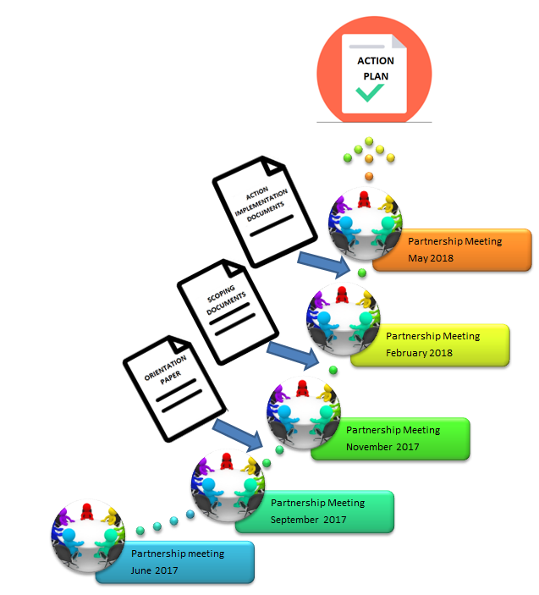

The action plan was sent for Public Feedback from June to September 2018 During this period, a wide range of stakeholders were approached, amongst others through workshops and presentations, and given the opportunity to provide their input. All received comments have been assessed, and the action plan updated and revised accordingly.

# 2 ACTIONS

The legislation on Public Procurement at EU level has recently been revised, and the current Public Procurement Directive [2] has been transposed by national governments. The new legislation is considered by the Partnership as up to date, and allows for the use of innovative and responsible public procurement. Thereto, the Partnership has seen little need to focus on ‘better regulation’ actions, but has instead chosen to focus its actions on ‘better knowledge’ and ‘better funding’. In short, the current legislation on public procurement offers the flexibility needed to facilitate innovative and responsible public procurement, but is still insufficiently used by the local authorities.

The Partnership proposes the following 7 actions (see 7 arrows in the graphic below), divided into 3 thematic areas (2.1 , 2.2 and 2.3):

**Figure 3: Seven actions of the Partnership divided into three thematic areas**

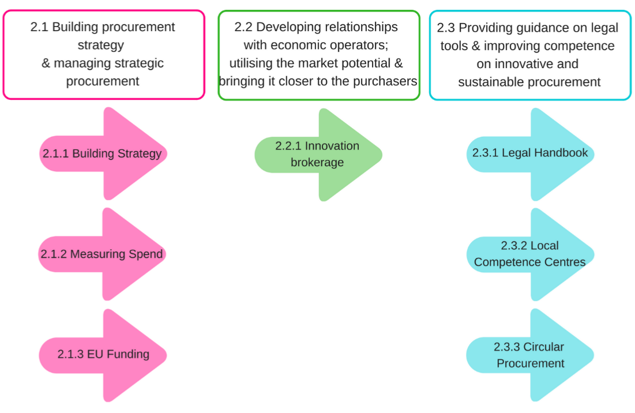

The 7 actions are all part of the cycle of public procurement and are aimed to support municipalities to successfully go through the stages of this cycle:

**Figure 4: Positioning of the Seven Actions of the Partnership within the Cycle of Public Procurement**

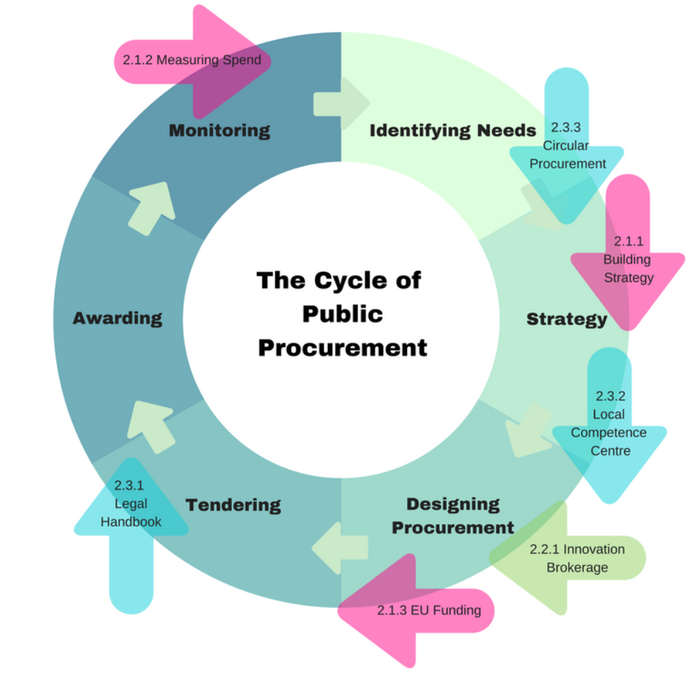

As presented by the figure above, innovative and responsible public procurement starts with building a procurement strategy (Action 2.1.1), which needs to take into account the needs of the cities, including economic, social and environmental objectives. The next stage focuses on the design of the procurement arrangements, including the development of local competencies. A dedicated focus of the Partnership is on local competence centres (Action 2.3.2), as well as the need to build competences in contributing to the circular economy – circular public procurement (Action 2.3.3). A specific way for boosting innovative public procurement is the use of Innovative Procurement Brokers (Action 2.2.1). Funding is important for cities to help starting innovative initiatives (2.1.3). The actual tendering process brings about a wide range of operational challenges and hurdles, many of which are legal in nature – hence the need for a Legal Handbook (Action 2.3.1). After the award of contracts, the implementation of works and services takes place. A crucial step includes the measuring of the impact of the spend, and its contribution to social, economic and environmental objectives of cities (Action 2.1.2).

## 2.1 Theme 2.1 Building procurement strategy and managing strategic procurement

### Action 2.1.1 Guidance on building city strategic procurement and how to manage strategic procurement

Public Procurement is an important strategic tool to solve different economic, environmental and social challenges. These challenges are translated into local policy targets. **Building a Procurement Strategy and managing strategic procurement** is needed in order to ensure that public procurement practices are aligned with the city’s broader goals. It implies that public procurement is no longer seen as a job to be done by the purchasers, but rather a tool for implementing various policy priorities.

This action aims at producing a guidance toolkit (including visual materials) that can help politicians and technicians in cities (especially mid-sized and small ones) in order to build their own Public Procurement strategy that allows the implementation of the global strategy of the city and face sustainability challenges. The provision of a guidance toolkit which meet the needs of cities would increase knowledge on the ground. In addition, on some essential legal issues clarifications could be sought from the European Commission, and could then be included in the guidance toolkit (better knowledge and/or regulation). Moreover, the publication of a guidance toolkit should ideally be supported by an exchange of good practices that need financial support (better funding). Finally, the publication of the guidance toolkit should be accompanied by dissemination activities and train-to-trainer educational package, possibly in part with regional competence centres, like events and training sessions.

The intended impact of the action is that more cities will create strategies for innovative and responsible public procurement, which directly implement several EU policy goals e.g. climate, innovation, circular economy, social cohesion. The direct impact of the guidance toolkit is to help cities (politicians and technicians) building their global procurement strategy and implementing it into their management practices. The expected impact is to use the full potential of the transposed European directives and the national rules. Analysing spend can help to provide data and an evidence base which can inform and improve the procurement strategy in a cycle effect (see Action under 2.1.2).

**Figure 5: This action links to several other actions of the Partnership**

**What is the specific problem?**

* Elected representatives in cities are sometimes not aware on the potential of the new provisions and of the strategic role that Public Procurement can play on the economic environmental and societal development of their city. Raising their awareness implies lots of attention;
* The large number of public authorities with different public procurement strategies within a specific geographic area makes access to public procurement for companies challenging;
* Lack of analyses of the public spend and of common methodology for measurement and wider impact. Lack of linkages between evidence and procurement strategies. Finding the steps into effectiveness metrics and management.

**Which action is needed?**

* To bridge the gap on knowledge of politicians and technicians, it’s essential to raise their awareness and knowledge on the strategic role of public procurement;
* To present the steps, process and their effects on cities organization when drafting and implementing a strategic procurement strategy (structure, decision-making, processes, competences);
* To adapt the public procurement strategy to the context of each city at both global or sectorial levels;
* To build partnerships between local authorities within a specific economic territory and shaping a common framework;
* To provide guidance on Procurement Spend, and how to follow, manage and measure the strategic effectiveness (strategic goals).

**How to implement the action?**

What has to be done?

| **Activities** | **Who** | **Estimated deadline** |
| --- | --- | --- |
| **Mapping of existing guides** and collection of good practices | External expert | done |
| **Hearing of market actors** (questionnaire, plus option for interviews) e.g. local chamber of commerce, national  - Experience of cooperation/market dialog activities with public procurement bodies  - Experience of other kind of strategic or stakeholder collaboration  - Suggestions for desired methods, activities e.g.  - City collaboration and public procurement in light of corporate sustainability – is there role?  - Analysis | Vantaa | December 2018  April 2019 |
| **Study visits**  - Finalising the methodological guide  - Study visit in Vantaa  - Study visit in Nantes  - Other study visits member cities  - Drafting outcomes of the visits | Nantes  Vantaa  Nantes  Haarlem  All | 16 March 2018  30 Mai 2018  October 2018  End of November 2018 |
| **Legal issues**  - writing the list  - answers by the Commission | All  DG Grow | September 2018  January 2019 |
| **Bibliography** | Technical secretariat, all | September 2018 |
| **Writing a guidance toolkit plan**  - drafting the structure  - drafting a detailed blue print  - writing the different chapters and texts  - consultation  - first proof reading  - layout and info graphic etc.  - 2nd proofreading  – info graphics | Nantes, Vantaa  All  Technical secretariat  All | September 2018  February 2019  March- June 2019  Mai and June 2019  September 2019  October 2019  December 2019 |
| **Dissemination**   * videos * events | All | End of 2019 & 2020 |
| **Collect of good practices :**  - drafting an updated questionnaire to be sent to cities who answered to the 1st questionnaire  - drafting more detailed questionnaire (A part: organisation model including political/strategic level, methods, process, B part: communication and market dialog practices; mapping the success factors and bottlenecks) for the cities who indicated interest into scientific research -> sending and answering  - Skype interviews on how A part: sustainability and innovativeness is integrated into (procurement) strategy, what are the operational models and how stakeholder collaboration is done B part: on practices and success factors of collaboration and contract management with sustainability/innovative/strategic results  - analysis  - sending the questionnaire and answering to  - shaping a template  – drafting a summery for each practice  - analysis with key findings | Nantes  Vantaa  Vantaa  Vantaa  Technical secretariat, all  Nantes  Nantes  Technical secretariat  Technical secretariat | 26 April 2018  May-August 2018  August – November 2018  January 2018-March 2019  December 2018-May 2019  June - August 2018  24 September 2018 |

Implementation risks

There’s a risk that such guidance books already exist. However we think that such guidance book/toolkit targeted to cities support the change management and creating the new processes, structures and decision-making model (especially to mid-sized or small cities) do not exist and that specific challenging issues that cities have to face have not been addressed. That should be the added value of such a guidance book. In order to mitigate this risk, an expert has been appointed to make the necessary preliminary research.

Another risk could be that the hand book doesn’t meet the expected impact due insufficient dissemination. That is why it is important to mobilise the relevant stakeholders in order to reach the target audience and to raise awareness about the hand book. This could for instance done through Action 2.3.2 (competence centres) but more importantly, support from the EU Institutions (European Commission in particular) will be crucial.

**Which partners?**

Leaders: Nantes; Vantaa.

Members: Haarlem; Preston; URBACT; Rijkswaterstaat; Gabrovo.

Stakeholders: All members of the Partnership included CEEP & EPSU (tbc).

### Action 2.1.2 Measuring spend and wider impact in European Cities

Monitoring the progress towards meeting local policy targets and a city’s broader goals (with regard to economic, environmental and social issues) can only be done by **Measuring the spend** related to public procurement, and by doing so in a systematic and harmonised way. The main objective is to understand where 14% of GDP across Europe goes geographically, sectorally and in business type terms and its wider economic, environmental and social impact.

The goal is to develop a common cross-Europe methodology for municipalities and other institutions to measure directly where their procurement spend goes and the impact it has (economically, socially and environmentally).

**Figure 6: This action is directly linked to the previous action**

**What is the specific problem?**

The specific bottleneck this Action Plan addresses relates to the needs of cities for objective data feedback loops for their procurement strategies in general to be accountable and evidence based. The partnership’s brief analysis has indicated an inability to communicate the positive effects of tenders.

Through data, cities can confirm if their aligned procurement strategy has led to smart, sustainable and inclusive growth, by using public funds innovatively and effectively. At present, it is not always clear which European data standards cities can use when collecting and processing procurement data from spend analysis and wider impact measurement.

To create feedback loops in Public Procurement, benchmarks and shared data on spending between contracting authorities in the EU must be inter‐operable and comparable.

When building procurement strategies, cities need to understand where procurement spending goes geographically and by industrial sector. The partnership will investigate the data standards available, and methodologies for expenditure analysis for exchange of procurement data between contracting authorities. It will also explore methods for identifying wider impact post-procurement.

The intended impact of the action is that cities are able to analyse spend and wider impact and shape strategy accordingly.

**Which action is needed?**

* Analysis of existing tools available;
* Methodology of how to analyse spend and measure impact;
* A common framework, for example an excel based tool into which municipalities and other institutions can input their procurement spend for a defined period and which then enables them to identify: geography of spend (national, regional, city-region, local, neighbourhood), the sectors which they are spending with, and the types of organisations they are spending with (e.g. SMEs);
* A common set of indicators for measuring wider economic, environmental and social impact and metrics to enable analysis to be undertaken.

**How to implement the action?**

What has to be done?

|  |  |
| --- | --- |
| **Activities** | **Estimated deadline** |
| **Reviewing and analysing existing spend and wider impact analysis tools** (what do existing tools look like and what are their positives and challenges) e.g. the ongoing DG CNECT study on the strategic use of public procurement for innovation in the digital economy — SMART 2016/0040 | July-October 2018 |
| **Develop a transferrable methodology** (simple to use tool which can be transferred across Europe) | August-December 2018 |
| **Test methodology with pilot cities** (e.g. cities in proposed Phase 2 URBACT transfer network, and other interested cities) | January- September 2019 |
| **Potential study visits** to cities which currently analyse their spend and / or measure wider economic, environmental and social impact |  |
| **Training for procurement practitioners in use of tool** (utilising Partnership as a lever and other European Programmes) | January - June 2019 |
| **Discussions around how spend and wider impact analysis** can be used to frame procurement strategies (thus link in to action point 1 around strategy) | On going |

Implementation risks

* Lack of involvement from cities
* Lack of staff time, capacity and resources
* EU legislative perceived barriers and narrow perceptions that spend analysis favours local contractors – it does not
* Sustaining measurement over a period of time, particularly given capacity challenges

**Which partners?**

Leader: Preston,

Members: URBACT, EUROCITIES, Haarlem; Rijkswaterstaat; Nantes; Vantaa; Gabrovo, Larvik.

Stakeholders: DG GROW, DG CONNECT; URBACT transfer network cities (Pamplona, Vila Nova de Famalicao); other cities currently undertaking spend analysis (Preston and anchor institutions).

**Which timeline?**

Remainder of 2018, with implementation in 2019, see section above for timeframes.

### Action 2.1.3 Recommendation(s) for seeking future EU funding for joint cross-border procurement, procurement of innovation, strategic procurement in particular social procurement and circular procurement

Local authorities need financial support to be able to introduce novelties into their procurement strategies and processes (social procurement, circular procurement, procurement of innovation, joint purchases and cross-border procurement). In that way innovative and responsible procurement can lead to short and long term savings and provide financial incentives, e.g. through economies of scale related to the procurement of larger volumes of goods and services. However these will not always be able to offset costs or risks related to innovative and responsible public procurement – hence questions of **Funding** merit specific attention as well.

The intended impact of the action is that cities involved in projects can seek financial support from the European Commission in order to be able to develop or reinforce their circular procurement policies, procure innovation, do joint-cross-border procurement and develop or reinforce strategic procurement, in particular social responsibility in their public procurement processes.

**Figure 7:** **There is a clear link to other actions of the partnership**

**What is the specific problem?**

Cities need financial support to be able to introduce novelties in their procurement strategy and processes: for instance for developing ‘circular procurement’, for introducing social responsibility in their procurement and for procuring innovation and joint-cross border procurement.

**Which action is needed?**

Cities need financial support to develop projects to learn from more advanced cities (replication projects) in circular procurement and strategic procurement, in particular social responsibility through procurement, to procure innovation (develop the tender process and documents) and to develop ‘joint cross-border procurement’.

* The rationale behind the action is that innovative and responsible procurement is sometimes more expensive than traditional procurement (e.g. market failure);
* Cities need support to address risks, e.g. one could consider building a pot or a contingency which could act as a guarantee - that could be used when something goes wrong with innovative procurement – it could provide a real incentive to take some more risks and test new processes. Such a guarantee could be built up at national or regional level (e.g. as part of the local competence centres, and funded under the kick-back schemes – Action 2.3.2);
* Cities need financial support to develop projects where they could learn from more advanced cities (replication projects) in circular procurement and strategic procurement; in particular social and fair trade procurement; to procure innovation (develop the tender process and documents) and to develop joint cross-border procurement.

The concrete output will be recommendation(s) to the European Commission, European Parliament and Member States on seeking future EU funding for joint cross-border, procurement of innovation, strategic public procurement including social responsibility and circular procurement.

**How to implement the action?**

What has to be done?

|  |  |
| --- | --- |
| **Activities** | **Estimated Deadline** |
| **Desk research:** How and where cities find the relevant information about existing funding for public procurement of innovation and strategic public procurement including joint cross-border procurement – which sources of funding are currently available for cities (Horizon2020, COSME, ESIF); | Summer 2018 |
| **Develop a rationale** to explain why cities need to seek this EU financial support and recommendations on what kind of financial support cities need | October 2018 |
| **Workshop** | November 2018 |
| **Recommendations** | December 2018 |

Recommendation(s) should be ready and disseminated to the relevant DGs in the Commission in time to be assessed before the future budget is adopted.

In May 2018, the Commission presented its proposal for future EU priorities and budget (Multi-annual financial framework for the period 2021 – 2027). The draft regulations for each EU programme will be published still in May 2018. Then, these proposals will be discussed in the Council and the European Parliament. In this phase, the input on funding could be very valuable. The Commission would like the negotiations on the budget to be finalised by May 2019.

Develop a rationale to explain why cities need to seek this EU financial support and recommendations on what kind of financial support do cities need.

Evidence: some reports demonstrate the need to invest in cross-border procurement: DG Grow study, produced in 2017 on measuring the impact of cross-border penetration in procurement:

<https://publications.europa.eu/en/publication-detail/-/publication/5c148423-39e2-11e7-a08e-01aa75ed71a1/language-en>

**Which partners?**

Leader: EUROCITIES

Members: Nantes Metropole and Haarlem

Stakeholders:

* All cities and networks members of the partnership;
* EIB;
* OECD;

Experience of experts working in Managing Authorities for ESIF; especially ETC/CBC programmes could be used. They could come up with practical examples or practical problems they have encountered in implementation;

We could also gather feedback on implementation of support from Horizon2020 and COSME.

## Theme 2.2 Developing relationships with economic operators; utilising the market potential and bringing it closer to the purchasers

### Action 2.2.1 Innovation procurement brokerage

Much innovation can come from the market potential, and bringing this market potential closer to the purchasers is important, e.g. by pre-procurement engagement of market parties. **Innovation procurement brokers** can play a crucial role in capturing this innovation and by promoting the spreading and take-up of innovative procurement practices.

The objective of this action is a more efficient public sector by means of a new paradigm of interaction among public and private players that contributes to fully exploit the innovation capability of the market.

The expected impact of implementing the action on a medium to long term will be an increase in the matching system among public buyers and suppliers within the Union. Consequently, it may create synergies, boosting the innovation process and creating new potential markets. It might increase the outreach of the EU directives on public procurement with specific regard to PPI (Public Procurement of Innovation) and act as a capacity building device for local, regional and national administrations.

**Figure 8: Innovation procurement brokerage links to two other actions**

**What is the specific problem?**

On the suppliers´ side, early interaction with the contracting authority and the explicit communication of a clear demand for innovation are known as success factors. In a tender situation, suppliers are often left without enough time to react, particularly if contracting authorities ask for innovative products. Since the notion of ‘economic operators (suppliers) has to be interpreted in a broad manner so as to include persons **firms, branches, subsidiaries, partnerships, cooperatives, limited companies, universities,** **social entrepreneurs and local innovators, public or private** [*Procurement directive (14)], the issue of defining practical way of interaction between contracting authorities, innovation broker(s) and suppliers is critically complex and has to take in account the specific procurement procedure (competitive dialogue, innovation partnership, pre-commercial procurement …).*[3]

Specifically, the links between start-ups offering innovative solutions and innovative SMEs, on the one side, and public buyers who may be willing to procure from them, on the other side, are often weak and do not arise spontaneously. 'Innovation procurement brokers' can help to build or strengthen them.”

The introduction of Innovation procurement brokers should be aimed at mitigating and solving the former issues, offering a concrete support to public buyers. Their role should be aligned to the policy objectives which led to the introduction of the concept of innovation in the directives:

*Research and innovation, including eco-innovation and social innovation, are among the main drivers of future growth and have been put at the centre of the Europe 2020 strategy for smart, sustainable and inclusive growth.* [*Procurement directive* (47)]. *[4]*

Generally, Public Procurement of Innovative solutions (PPI) happens when the public sector uses its purchasing power to act as early adopter of innovative solutions which are not yet available on large scale commercial basis.

Competitive Dialogue procedures are usually applied in circumstances where the needs of the contracting authority cannot be met without adaptation of readily available solutions, greater flexibility is needed, for highly complex and risky projects, and/or technical specifications cannot be established with sufficient precision by the contracting authority. Competitive dialogue allows buyers to negotiate proposed solutions with bidders.

More specifically when a need for the development of an innovative product or service or innovative works and the subsequent purchase of the resulting supplies, services or works cannot be met by solutions already available on the market, contracting authorities have access to a specific procurement procedure, named “Innovation partnership”. This specific procedure allows contracting authorities to establish a long-term innovation partnership for the development and subsequent purchase of a new, innovative product, service or works[5]. The innovation partnership can be structured in a way such that it can provide the necessary ‘demand-pull’, incentivizing the development of an innovative solution without foreclosing the market [*Procurement directive* (49)]. *[6]*

Pre-commercial procurement is used to procure research and development services, up to the prototyping or first test production stages.

Generally, in every type of innovation procurement procedure, contracting authorities may need a process of brokerage to boost the interaction with the market.

The goal of the action is to facilitate the early engagement of (solution providers) innovators in order to satisfy public demand of innovation.

The partnership has to investigate the specific need for innovation procurement brokerage[7] between demand and supply-side, the organisational model, the subjective features of an “ideal” innovation procurement broker and how it can practically support this interaction between public buyers and economic operators.

Identify ways, procedures, policies to enable the involvement of civil society and local communities in the co-creation of innovative solutions to urban challenges.

**Which action is needed?**

Guidelines for both the implementation and management of the “innovation (procurement) broker”, conceived at regional, national and EU level, with the close involvement of EU cities.

Below a list of features is reported that have been identified as significant relying on information collected so far:[8]

“Innovation Broker can be any institution with the capacity and purpose to match nascent innovation with a corresponding need on the demand side.

The broker is meant to be part of the overall innovation life-cycle and a driving force behind the public procurement of innovation. It is **actively engaged in funnelling ideas from potential suppliers of innovation to networks of potential buyers** **of innovation**, be it cities, hospitals, civil protection authorities or any other relevant public buyer network. And – inversely – it can communicate to the relevant industry the needs of the public buyers. Innovation brokers can also facilitate the preparation of innovative ideas for specific public procurement procedures.

Their tasks may include:

* Organising public buyers interested in public procurement of innovation into networks (qualitative demand aggregation?) to share knowledge and exchange best practice.
* Advising public buyers on how to define their needs that could potentially be satisfied through public procurement of innovation.
* Identifying promising innovative solutions that are suitable for matching the needs of the public buyers. Typically, such solutions have potential for commercialisation and scaling up of disruptive rather than incremental innovation.
* Adopting new procedural tools to create space for a more collaborative dialogue between economic operators, civil society organizations, as well as urban and social innovators to co-design and co-create innovative solutions.

Depending on their business model they can also facilitate access to funding and help manage intellectual property rights. On the other hand, innovation brokers should not act as sellers of unsolicited proposals to the public buyers, nor are they substitutes for public buyers.”

Innovation procurement brokers should take into account that the Urban Agenda for the EU establishes that “*In order to address the increasingly complex challenges in Urban Areas, it is important that Urban Authorities cooperate with local communities, civil society, businesses and knowledge institutions*” (preamble) and calls upon “*Urban Authorities to continue to work together with Regional Authorities, the private sector, local communities, knowledge institutions and civil society in bringing forward the Urban Agenda for the EU*” (point 31).

At the same time Innovative procurement brokers should take into account the policy objective of the Urban Agenda for the EU is (i) “To recognise the potential of civil society to co-create innovative solutions to urban challenges, which can contribute to public policy making at all levels of government and strengthen democracy in the EU” (point 52 in section X; (ii) when it comes to urban procurement “The objective is to use this powerful tool to address social and environmental objectives and to do more with less. This will cover innovative approaches in procurement.” (point 12 in the list of priority themes).

According to the orientation paper of the Partnership on Innovative and Responsible Procurement “The members of this partnership interpret the word Innovative from the title as a reference to PPI”.

**How to implement the action?**

What has to be done?

| **Activities** | **Estimated deadline** |
| --- | --- |
| **Desk research:** The concept of innovation broker is more frequently used in “open innovation” and Business to Business (B2B) frameworks. This latter consists of business that is conducted between companies, rather than between a company and public buyers, which is the focus of the present action. Therefore, we have to identify early practical experiences, with a specific focus on the involvement of the public sector, also to avoid overlaps and duplication. (e.g. the European Innovation Brokers pilot project launched in late 2017*,* the Reggio Emilia Region innovation broker which will invest more than 1.2 million on generating innovation to review public expenditures for the acquisition of works, supplies or services; Agid is launching a national platform for “procurement of innovation” which may also act as innovation broker …)  This activity is supported by an external expert. | June 2018 |
| **Regulation analysis:** Analysis of emerging innovation broker’s models, definition of the typical tasks of an innovation procurement broker, analysis of:   * compliance with the EU principles on procurement; * coherency with current procurement procedures; * coherency with the EU legislation and policy frameworks on open innovation and other forms of support or investment on innovation. Questionnaires and interviews to DG-GROW, EASME, contracting authorities in selected countries, selected partners (Turin, Larvik).   Agid, LUISS and joint work with action 2 and 3 (legal aspects). | December 2018 |
| **Innovative solutions for effective brokerage:** Early experiences show the complexity of the brokerage function. The output of the activity is the conceptual design of functionalities, tools and knowledge bases to support innovation brokerage. Cognitive procurement, the branch of procurement which makes a significant use of predictive tools and artificial intelligence, could be applied to support knowledge based matchmaking between the demand and the offer of innovation.  Agid and an external expert to support this activity. | December 2018 |
| **Institutional and multilevel governance design:** define how the innovation broker role can be implemented at the urban/local level, what procedures they could apply to spur experimental actions at the urban/local level and how their action could be networked into the European or Country-specific institutional configuration at the regional and/or national level and/or European level. This activity is connected with Action 4 “local Competence Centre”.  DG-REGIO, EASME, contracting authorities in selected countries.  Agid, LUISS and joint work with action 2 (legal aspects) and action 4 (Local competence centre), start July 2018. | December 2018 |
| **Drafting guidelines for the implementation and management of innovation procurement brokers:** draft reports will be released at the end of each activity. The final coordinated report is expected to be issued in April 2019 | April 2019 |
| **Ongoing work:** participation in the work of and partnership with the Commission's innovation procurement broker pilot | Q3 of 2018. |

Implementation risks

The concept of “innovation procurement broker” is per se new, especially in the public sector. So, we perceive as potential risk the lack of available experiences and information, which then may be not sufficient to formulate reliable guidelines. Nonetheless, a mitigation of this risk is foreseeable by mean of a deep analysis of current experiences within the “open innovation” framework.

**Which partners?**

Leader: Italy/Agid, LUISS Guido Carli University

Members: Larvik, Turin

Stakeholders:

* AgID (Agency for Digital Italy)
* DG GROW
* DG REGIO
* Executive Agency for SMEs (EASME)
* European Assistance For Innovation Procurement (EAFIP)
* Contracting Authorities of selected countries
* Cities and Member State(s) in the Partnership will be probably approached to participate in a pilot of a platform
* Universities particularly engaged in bridging social and technological innovation actors with local and national public authorities through their third mission work

**Which timeline?**

Actions to be planned and prepared during 2018 and implemented starting from 2019 (or sooner if applicable). In any case, recommendation(s) should be ready and disseminated to the relevant DGs in the Commission in 2019 at the time when the calls for the next programming period programmes will be prepared.

## Theme 2.3 Providing guidance on legal tools and improving competence on innovative and sustainable procurement

### Action 2.3.1 Legal Handbook Innovative Public Procurement

In the preparatory stages of the work of this Partnership, much attention has been put on two interrelated bottlenecks: knowledge and legal certainty. The practical experience from the partners has confirmed that these bottlenecks are interrelated: those practitioners with more knowledge and experience are better equipped to address issues of legal certainty, and assess the risks related to innovative public procurement.

A **legal handbook** is a tool for practitioners to gain such knowledge and experience, as it allows practitioners to learn from others at a much faster rate. For more focus the innovation procurement guidance will build on the existing guidance(s) and potentially expand or clarify some aspects of it.

**Figure 9:** **The action links to various other actions**

**What is the specific problem?**

*Complexity, uncertainty and risk aversion in regard of procurement law.*

The challenge for many European cities seems not necessarily to be the EU law on procurement, but rather how to apply the Directives that are transposed in national laws at their local level. The European Directives seem to provide the right balance between compulsory minimum requirements, and opportunities for flexibility and collaboration with economic operators. There are legal instruments and tools for public procurement of innovation and for meeting social and environmental challenges. Cities in general have a desire to address wider challenges through tendering contracts for public services, yet see the procurement-process as uncertain, complex and thus risky. Legal and other types of risk aversion within contracting authorities play an important role in procurement of innovation. Innovation also requires mitigating risks and reducing legal and other uncertainties where possible. The important questions to answer are: How and why does the current legal framework lead to feelings of uncertainty and therefore risk aversion by the employees of contracting authorities who have to work with it and what prevents them from using the full potential of the legal instruments and tools for the procurement of innovation? How can we mitigate these uncertainties and risk aversion?

Providing enough (practical) knowledge and explanation regarding the procurement law in order to reduce the feelings of uncertainty, the perception of complexity and therefore the risk aversion of the people who are responsible for the procurement of innovation. (This overall goal is the “legal handbook innovative public procurement”.)

Updates after the end of the partnership: It would be very important to keep the handbook updated, because only then our work will have a lasting impact. So we propose some kind of “permanent procurement congress” organized by the EU, where the relevant members meet once or twice a year and contribute for an updated publication.

**Which action is needed?**

The legal handbook on innovative public procurement will contain a practical guideline regarding legal aspects for the procurement of innovation. These legal aspects could be for instance:

* Legal interpretation of the leeway local authorities may use on specific issues like the “link of the awarding criteria with the subject matter”;
* Legal aspects of market consultations;
* Legal aspects of dialogue phases / stages of the “competitive dialogue”;
* Legal aspects of the innovation partnership.

Other legal interpretations as well as the analysis of other legal aspects (antitrust, IP etc.) can follow, if necessary.

As the legal handbook is meant to be used by practitioners, it has to be written and presented in an understandable and usable way.

**How to implement the action?**

What has to be done?

| **Activities** | **Estimated deadline** |
| --- | --- |
| **Analysing the European Procurement Law:** This milestone contains the **identification** of the relevant legal parts of the EU Directives on Public Procurement regarding the procurement of innovation. After identifying these legal parts we have to identify the relevant problems as well as the corresponding recitals of the EU directives, already existing jurisdictions of the ECJ and important scientific publications. This information will be the basement for our further work. Analysing other legal aspects, as far as they are relevant regarding the procurement of innovation. (These analyses can contain legal interpretations. The focus will be the EU law, but it can also be widened to relevant aspects of national legislations.) | October 2018 |
| **Creation:** In the creation phase we will invent and produce our legal handbook based on our previous findings we have collected in our information basement. Therefore we will have to consider the positions of the European Union and of the ECJ; furthermore we have to weigh the arguments we found in the relevant and important scientific papers as well as the input we gained from the interviews and discussions. | September 2019 |
| **Researching** existing guidelines, handbooks and other publications regarding the procurement of innovation, and **implementing** useful chapters of these documents in our handbook. | December 2018 |
| **Interviews, Discussions:** With our “information basement” defined, we can step into exchanges with relevant institutions and individuals. Here our main goal is to get more knowledge and insights regarding the aspects of our information basement, because we have to focus on them. The results of these interviews and discussions will be added to our information basement in order to use it for our further work. The interviews and discussions can be carried out by personal exchange and by other means of communication | March 2019 |
| **Attending** conferences and meetings where the relevant aspects will be topics | Continue |
| **Promoting (the legal handbook):** As we want to do some public relations for our handbook, we can create a well-designed publication, translate it into the necessary languages, contact relevant institutions (national governments, important European cities, associations of cities throughout Europe etc.) and give lectures at important events about our "product". Of course, our handbook should be downloadable from relevant websites and be provided in different formats (pdf, word etc.) and will contents visual material if necessary. The handbook should not be published by a commercial publisher, as we want to avoid any legal issues regarding intellectual property; everybody should be able to download it and use it in any way possible – for free. | December 2019 |

Implementation risks

The main risk is that there already exist guidelines, handbooks and other publications that contain more or less everything we want to implement in our legal handbook innovative procurement. Therefore we already started a very profound research of mapping expertise. Other risks could be: inefficient time planning, a too great amount of sub-tasks or activities, a practical guideline that is too “theoretical”.

**Which partners?**

Leader: Munich

Members: Vantaa, Gabrovo, Italy, DG GROW, LUISS Labgov, Rome, CEMR, Nantes, KEINO

Stakeholders: Institutions, such as universities, national and local governments and (national, regional, local) competence centres, as well as academics and other individuals, such as employees of contracting authorities. Of course, all the members of the Partnership and the European Commission, especially DG REGIO and DG GROW, will be involved.

**Which timeline?**

The basic activity is the analysis of the procurement law and probably other legal aspects. This analysis has to be complemented by the necessary research, by interviewing and discussing with experts and institutions. For the timeline see table above “Activities and estimated deadlines”. Updates after the end of the partnership: It would be very important to keep the handbook updated, because only then our work will have a lasting impact. So we propose some kind of “permanent procurement congress” organized by the EU, where the relevant members meet once or twice a year and contribute for an updated publication.

### Action 2.3.2 Develop a flexible and customisable concept for Local Competence Centres for innovative and sustainable procurement.

Learning can happen through cooperation and peer learning, namely through **Local competence Centres** which provide opportunities for training and skills development, but also for networking, technical assistance provision and potentially joint purchases. Such local competence centres are specifically valuable for smaller and medium-sized cities, and can complement new and on-going national and EU-wide initiatives, like e.g. Procure2Innovate project that was launched by DG CONNECT.

The objectives of the action:

* Improved capabilities - knowledge and skills – of local buyers (and external experts helping them) in conducting innovative and sustainable public procurement, including the pre- and post-procurement/ tendering phases.
* Better awareness of innovative and sustainable public procurement, their benefits, and proven solutions, and a greater willingness to engage.

**Figure 10:** **Local Competence Centres are related to the following actions within the partnership**

**What is the specific problem?**

Competence building

In total there are almost 100,000 municipalities in Europe (LAU2 (Local Administrative Units) in Eurostat’s nomenclature).[9] A great part of public procurement in Europe (even above the EU value thresholds) is undertaken by these municipalities, by the public bodies and companies under their command, or by associations of municipalities.

Based on experience, the organisations responsible for planning and conducting public procurement at local level vary considerably in size and form, and many of the smaller municipalities and municipal bodies and companies do not have expert procurement officers. The competence of local procurement officers on the details of applicable law, and on the processes and general know-how of innovative procurement varies from little to sufficient - but their competence on what the municipalities actually need to buy is high. To strengthen local ownership of the procurement and minimising the risk of yielding inflexible and ineffective solutions, it is useful to expand local capabilities in innovative or sustainable public procurement, rather than relying on the expert knowledge and skills of centralised procurement bodies at national level.

Since a great amount of procurement is performed locally, and knowing that by interacting, working together and exchanging best practices local and regional leaders are better able to tackle the challenges of innovative public procurement, it is important to establish Local Competence Centres (LCC) which will enable even smaller local contracting authorities and entities – procurement officers within these organisations and external public procurement experts helping them – to be prepared to successfully conduct such procurement.

More specifically, building a circular economy requires joining forces of municipalities on at least a regional level. As a result, circular procurement practices should also be organised at this level. LCC’s can provide for this need.

LCC’s can cover any number of municipalities (ranging from 2 to 20, 30 etc, depending on local circumstances) that share a natural connection, based on, for instance, geography, procurement needs or their level of development.

The LCC’s could also be partners for the Regional and National Competence Centres, especially by being an intermediary that can communicate the more specialist competence of the Regional and National Competence Centres to the municipalities and other local contracting bodies. The LCC’s can help convert theory into practice.

Their work will be focussed on small and medium-sized towns, but they can also involve and support larger municipalities in their innovative public procurement efforts and would certainly benefit from access to the experience of larger towns and cities.

Meeting the projected goals of innovative and sustainable procurement the LCC’s need a broad scope: not only legal competence, but a specialised expertise and collaboration in a wide range of fields is needed. In particular, an effective strategic approach to the pre-tendering phase (and even before considering that a concrete procurement/tendering process will be undertaken) is fundamental for utilising public procurement in the most strategic manner possible. Effective contract management, post tendering, is also fundamental to ensure that the objectives of the procurement are met during the contract phase.

Knowledge resources, tools and risk management know-how (i.e. how to buy innovation without taking unnecessary (financial, legal, political, functional) risks) need to be enhanced.

By sharing knowledge and by working together, local buyers (municipalities and their public bodies and companies) can be encouraged to engage in innovative and sustainable public procurement, and can have access to very practical know-how (based on the strong expertise and experience accumulated at the LCCs) on how to conduct these. It can also lead to municipalities having a role in supporting ‘Lead Markets’ by procuring as first buyers much needed innovative goods and services, as well as contributing to climate change, environmental and social goals by fostering a more sustainable development.

**Which action is needed?**

The partnership proposes a flexible concept – adaptable to the local situation – for Local Competence Centres for innovative and sustainable procurement.

For the purpose of this action plan we use the overall term ‘competence centre’ as an umbrella for a formal or informal organization or network whose activities might (but do not necessarily) include: collecting experience and evidence, knowledge sharing[10], helpdesk services, training courses and joint procurement. We will explore the different possible models of such an organization or network.

In describing the various options, we will examine their plusses and minuses, for example risks/practical problems a model may lead to (such as costs, lack of time, of ownership etc.). This exploration also includes the long-term development or evolutionary path of the initiative and how this may differ locally.

Part of the action will be to explore the different levels at which a competence centre can be set up in given Member States – that is the most effective level of operations that is smaller than the national level.[11] We will also need to define what is ‘local’ and what is ‘regional’? This may vary in different countries, depending on how they are structured (Länder, provinces, counties, metropolitan areas, etc.).

We will also need to consider where the mandate for the competence centre lies. This could be with a specific territorial government level like the province, county or a metropolitan region – if they have the sufficient administrative or self-government responsibilities, funding and capabilities.

Furthermore, we will look into ways of funding the initiatives. If the local competence centre performs joint procurements, a possible option is that the centre is self-subsidized by the savings from mutual procurement on behalf of members. They can also be financed by the member municipalities who provide resources (in money or manpower). Centres might also ask funding from the EU, from their national government or from the government level that has the mandate (for example the province).

The benefits of interaction of these LCCs with public-procurement-focussed competence centres organised at higher levels (for example national competence centres) will be discussed, and also the building of formal and informal relations with other competence centres across Europe. It will be taken due account of the existing ecosystem of support organisations and bodies in which the new LCCs will fit in.

**How to implement the action?**

What has to be done?

* Collecting existing initiatives of competence centres (status, activities, organisation and methods, resources, funding sources, good practice etc.);
* Exploring core strategic questions in setting up a concept for local competence centres, such as: their mission, who will they work for; are they going to be independent or under a common umbrella; will they work with a common methodology and pooling of resources; who will set them up; how; can other anchor institutions be involved; which possible models can be distinguished;
* Funding: the question of funding (amounts and sources) of the competence centres should be addressed in order to make the concept a realistic venture;
* Outlining which tools, knowledge, experience and (human) resources can or have to be component parts of the concept; this will be greatly dependent on the scope of action of the LCC, e.g. if training and the exchange of risk mitigation techniques are part of the task of a competence centre (therefore different models need to be considered);
* Defining possible priority policy areas of competence centres;
* Scoping possible intermediation activities of a local competence centre (data exchange, such as financial expertise, market knowledge and best practices);
* Liaising with national competence centres on strategic procurement (e.g. innovation procurement competence centres);
* Networking with existing competence centres and exploring the way local competence centres can collaborate – as a network - on a national and possibly cross border (European) level;
* Writing an instruction with an outline for the concept of a local competence centre.

In order to make sure our action has any/the desired impact, we will explore the opportunity of working together with the initiative Procure2Innovate Project[12]. This is an initiative led by the German national competence centre that aims to set up a European network of national procurement competence centres for innovation procurement. It consists of 5 existing and 5 new national competence centres.

We will also connect to the SPP Regions project, which comprises of a number of seven European (regional) public sector networks for sustainable procurement and innovation within public procurement.

Close collaboration with both projects could enhance the identification of existing initiatives and hopefully, the visibility of our initiative and an expeditious dissemination of our activities.

Furthermore, we will put our theories into practice during the process of developing the concept for a local competence centre. Starting with the group of participating municipalities in our partnership, we will try to find parties that have an interest in setting up a local competence centre. In this way we not only help these parties to get going but also hope and expect to strengthen the added value of our concept.

The expected impact of implementing the action on a medium to long term will be the EU-wide establishment of Local Competence Centres, and a high level of uptake among European municipalities, leading to an increase in the use of innovative and sustainable public procurement at local level.

Implementation risks

* Lack of involvement from cities
* Time
* Lack of resources (human and financial) to develop and organise a concept of a local competence centre; to implement the pilots.

**Which partners?**

Leader: Haarlem

Members: Larvik, ICLEI, KEINO, Eurocities, EC (DG REGIO, DG GROW and DG CONNECT)

Stakeholders: PIANOo, URBACT, Cities and Member State(s) in the partnership will be approached to participate in setting up local competence centres.

Which timeline?

| **Activities** | **Estimated deadline** |
| --- | --- |
| **Implementation of the activities** | August 2019 |
| **Setting up local competence centres** | November 2019 |
| **Final evaluation** | December 2019 |

### Action 2.3.3 Competence building in Circular Procurement

Learning is key to innovative and responsible public procurement, and specific efforts are required in new policy areas where competences are still underdeveloped, such as **Circular procurement competences**.

**Figure 10: The action links to two other actions**

**What is the specific problem?**

Several bottlenecks regarding knowledge, that hinder the use of circular procurement, have been identified. Knowledge related gaps we want to fill are amongst others that procurement procedures for circular procurement are unknown, possibilities given by the new directives/regulations are not spread, available circular solutions (products/services) are not known, the differences between general public procurements and circular procurement is to many buyers and their clients, managers, policy advisors and budget holders not clear, there is a need for cultural changes as central procurement departments are not always keen to promote circular/green procurements, existing good practices are not being sufficiently promoted and there is a lack of available training and education on circular procurement for decision makers, professionals and students.

The goal of this action is to Share and 'unlock' experience, knowledge and insights on circular procurement with public buyers and their clients, managers, policy advisors and budget holders. We want to show what circular procurement is, and why it can be a valuable tool for European cities. Offer knowledge that is practical and directly transferrable to the work of public buyers.

Provide managers/politicians who want to use circular procurement as a strategic tool with an easily accessible and ready-to-use training solution for them and for procurement staff.

The expected impact of implementing the action on a medium to long term will be an increase in the use of circular procurement in the cities that have made use of the circular procurement workshops or academy. The direct impact of more circular procurement is that it directly creates working circular business cases: circular procurement has real impact on circular economy. The impact of this action may be strengthened also by the effect of other complementing actions in the partnership.

**Which action is needed?**

The main output we want to achieve is that public procurement officers in local and regional authorities (cities, municipalities, counties/departments, regions) across the EU are offered and attend workshops and trainings that support them to conduct circular procurement. We want to make knowledge on circular procurement easily available by providing conferences, workshops and training material that cities can use to build and develop competence for relevant staff. Knowledge and shared good practices build confidence and promote opportunities that are often needed for buyers and their managers to have the courage to use procurements as a strategic tool for circularity.

**How to implement the action?**

What needs to be done?

* Workshops and trainings

Based on knowledge, experience and the available workshop and training materials from the recent 10YFP UNEP Working Group 4c, the REBus project (LIFE+) and the current CircularPP project (Interreg) the following activities can be undertaken:

* + Organise/create a series of workshops and/or promote existing workshops, whose format and content can be easily reproduced by different stakeholders in other locations and other languages. The first series of workshops could be hosted by CEMR in its premises in Brussels and be addressed to 30/40 participants.
  + Organise/participate in awareness raising workshops for public authorities. This can be linked to existing conferences such as EcoProcura or the Circular Procurement Congress. Presentations of results at circular economy / procurement related events, mainly at national and local level.
* Circular Procurement Academy

Based on the experience and materials from the Dutch 'Circular Procurement Academy' a knowledge package/curriculum for a Circular Procurement Academy will be put together that can be used/adapted to different cities and Member States. Create a set-up for training sessions with knowledge resources and best practise examples. Build on the experience from PIANOo (<https://is.gd/3FjVIq>) in the Netherlands.

Implementation risks

The main risk for implementation of the action would be a lack of resources (human and financial) to develop and organise the workshops and the academy. Especially the academy will take some effort and spending, this needs local decisions in the cities, regions and/or Member States.

We will seek to mitigate any risk of the workshops/academy not being used by looking for ways to finance participation for instance through use of Peer 2 Peer funding from the EU Commission.

**Which partners?**

Leader: Rijkswaterstaat, NL

Members: CEMR and DG REGIO

Stakeholders:

* PIANOo, Rijkswaterstaat, CEMR, DG ENV and DG REGIO. Other actors with practical experience with conducting circular procurement will be approached to support the development of the materials.
* Cities and Member States in the partnership will be approached to co-organise the workshops and trainings.
* CEMR members organisation of local and regional governments, based in Brussels and/or abroad.

**Which timeline?**

Workshops and trainings

|  |  |
| --- | --- |
| **Activities** | **Estimated deadline** |
| **Organise/create a series of workshops and/or promote existing workshops.** | September 2018 – continuous (A schedule will be made) |
| **The first series of workshops** could be hosted by CEMR in its premises in Brussels and be addressed to 30/40 participants. | September or October 2018 (exact date to be decided) |
| **Organise/participate in awareness raising workshops** for public authorities. This can be linked to existing conferences such as EcoProcura or the Circular Procurement Congress. Presentations of results at circular economy / procurement related events, mainly at national and local level. | September 2018 – December 2019 (a schedule will be made) |

Circular Procurement Academy

|  |  |
| --- | --- |
| **Activities** | **Estimated deadline** |
| **Put together a knowledge package/curriculum for a Circular Procurement Academy** | September 2018 - December 2019 |
| **Create a set-up for training sessions with knowledge resources and best practise examples** | September 2018 - December 2019 (Together with Circular Economy partnership) |

# RECOMMENDATIONS

Our Recommendations are meant to suggest good policies, good governance or good practice examples which could be used for inspiration. Some of these were initially considered as actions for the action plan, others have been conceived as recommendations from the start. All recommendations have the aim to contribute to the uptake of the innovative procurement within an urban context.

EU level could:

* Consider EU funding for joint cross-border procurement, procurement of innovation, strategic procurement in particular social procurement (i.e. using social clauses and award criteria in tendering processes and contracts) and circular procurement.
* Provide legal interpretation aiming at increasing legal certainty.

Member State level could:

* Enable the exchange of Innovative and Responsible Public Procurement amongst cities. Member States could contribute to the uptake of Innovative and Responsible Public Procurement in cities by promoting the exchange of good practices within a national context (e.g. platforms, FAQ’s, legal doctrine).
* Enable capacity building on Innovative and Responsible Public Procurement. The uptake of Innovative and Responsible Public Procurement could be enhanced by capacity building of (municipal) staff, especially so in medium-sized and smaller cities.
* Enable training on Circular Procurement. The uptake of Circular Procurement can be enhanced by training of (municipal) staff, especially so in medium-sized and smaller cities.

City level could:

* Develop their own procurement strategy that allows the implementation of the global strategy and face sustainability challenges. This should be co-constructed with the operators with the operators and stakeholders who are part of the ecosystem. Therefore cities should address their own governance (e.g. management, organisation).
* Develop indicators for measuring impact of procurement on social, environmental and economic aspects. In order to be able to measure and monitor the future progress towards the innovative (including circular) procurement, cities are encouraged to build monitoring systems (measuring spend) and indicators, taking into account environmental, economic and social indicators.
* implement strategic public procurement. Municipalities have an important lever at their disposal through the public procurement of goods, services and works. They can actively apply circular economy principles through applying circular economy considerations in eligibility and award criteria (e.g. the use of Life Cycle costing).
* Offer training on innovative and responsible public procurement for relevant staff and decision makers and facilitate cooperation with other cities to share knowledge and experiences.

# LINKS WITH OTHER COMMITMENTS

## Link with the cross-cutting issues

Article 12 of the Pact of Amsterdam requests that Urban Partnerships consider in their work the relevance of a range of cross-cutting issues (listed as 12.1 to 12.11). After all, the complexity of urban challenges requires integrating different policy aspects to avoid contradictory consequences and make interventions in Urban Areas more effective. It is understood that competences and responsibilities differ amongst participants and that the EU does not have competences on some of these issues.

The Action Plan foresees specific attention to be paid to the following cross-cutting issues:

12.1 Effective urban governance, including citizens participation and new models of governance.

12.2 Governance across administrative boundaries and inter-municipal cooperation: urban-rural, urban-urban and cross-border cooperation; link with territorial development and the Territorial Agenda 2020 (well-balanced territorial development).

12.3 Sound and strategic urban planning (link with regional planning, including ‘research and innovation smart specialisation strategies’ (RIS3), and balanced territorial development), with a place-based and people based approach.

12.4 Integrated and participatory approach.

12.5 Innovative approaches, including Smart Cities.

12.6 Impact on societal change, including behavioural change, promoting, among other things, equal access to information, gender equality and women empowerment.

12.7 Challenges and opportunities of small- and medium-sized Urban Areas and polycentric development.

12.8 Urban regeneration, including social, economic, environmental, spatial and cultural aspects, also linked to the brownfield redevelopment with the objective of limiting greenfield consumption.

12.9 Adaptation to demographic change and in- and out migration.

12.10 Provision of adequate public services of general interest (within the meaning of Article 14 TFEU in conjunction with Protocol Number 26).

12.11 International dimension: link with the New Urban Agenda (Habitat III) of the UN (to be agreed upon), the Sustainable Development Goals (SDGs, 2030 Agenda on Sustainable Development) of the UN and the Paris Agreement on climate change of December 2015.

First of all, it should be acknowledged that the topic of Innovative and Responsible Public Procurement itself is inherently cross-cutting, and that working on this topic is promoting cooperation across silos and sectors. Furthermore, Innovative and Responsible Public Procurement is a strategic tool to solve different social, environmental and economic challenges. In this way it can complement work done in all Urban Agenda partnerships, such as the partnerships on Housing, Jobs and Skills, Digital Transition, Urban Mobility etc. In particular, there is a link with the Partnership Circular Economy. The Circular Procurement was transferred from the Partnership Circular Economy to the Partnership Innovative and Responsible Public Procurement in the last half quarter of 2017.

Specifically, the partnership wishes to underline the importance and relevance of the following theme:

* *12.2 Governance across administrative boundaries and inter-municipal cooperation: urban-rural, urban-urban and cross-border cooperation*

Although cities are driving forward the circular procurement, it is acknowledged that effective markets for resources and waste require cooperation across municipal boundaries.





## New Urban Agenda & Sustainable Development Goals

The Urban Agenda for the EU is part of the EU’s commitment to both the New Urban Agenda and the 2030 Agenda for Sustainable Development. The actions addressed in this Action Plan are in accordance and correspond with the set commitments and goals in these international agreements. Innovative and responsible public procurement is a topic that touches upon several of the cities critical challenges, both in relation to social, economic and environmental issues.

# 5 TO CONCLUDE

As can be established from the previous chapter, there are many existing initiatives and projects that relate to the work of the Partnership. However, we feel that added value is to be found in the actions that the Partnership presents in this Action Plan. There are unexplored areas in the process of innovative and responsible public procurement. We defined 7 actions that we think will contribute to the main goal and objective of the Partnership, which is to promote public procurement as a strategic tool in realising social, economic and environmental policy goals of cities.

The Partnership invites all stakeholders within Europe to give feedback on this Action Plan.

# 

# 6 MONITORING

|  |  |  |  |
| --- | --- | --- | --- |
| **Action** | **Leader** | **Deadline** | **State of Play** |
| **Theme 2.1** |  |  |  |
| Action n° 2.1.1 Practical guideline on building procurement strategy | Nantes Metropole  Vantaa | December 2019 | Mapping of existing guides and collection of good practices has been done |
| Action n° 2.1.2 Measuring spend in European cities | Preston  URBACT | December 2019 | Started with reviewing and analysing existing spend and wider impact analysis tools. |
| Action n° 2.1.3 Recommendation(s) for future EU funding for joint and/or circular procurement | Eurocities | December 2019 | Started with desk research |
| **Theme 2.2** |  |  |  |
| Action n° 2.2.1 Innovation broker | Italy/Agid  Luiss | December 2019 | Desk research almost finished |
| **Theme 2.3** |  |  |  |
| Action n° 2.3.1 Legal handbook innovative procurement | Munich | December 2019 | Mapping expertise has been done |
| Action n° 2.3.2 Local competence centres | Haarlem | December 2019 | Mapping expertise has been done |
| Action n° 2.3.3 Competency building circular procurement | CEMR  Rijkswaterstaat | December 2019 | Started with putting together a knowledge package/curriculum for a Circular Procurement Academy. |

# ANNEX: EXISTING INITIATIVES AND PROJECTS

The Partnership has conducted an overview of existing initiatives, policies, legislation, funding instruments, working groups, networks, projects and databases, to avoid overlaps and duplication of work:

**1. Guidance material**

* Guidance on innovation procurement, European Commission: <https://ec.europa.eu/docsroom/documents/29261>
* “PUBLIC PROCUREMENT GUIDANCE FOR PRACTITIONERS (FEBRUARY 2018) on avoiding the most common errors in projects funded by the European Structural and Investment Funds” http://ec.europa.eu/regional_policy/en/policy/how/improving-investment/public-procurement/guide/
* Public Procurement of Innovation Guidance, http://www.innovation-procurement.org/about-ppi/guidance/
* Public Procurement as a driver of innovation in SMEs and public services, https://publications.europa.eu/en/publication-detail/-/publication/f5fd4d90-a7ac-11e5-b528-01aa75ed71a1
* European Assistance for Innovative Procurement (EAFIP) toolkit, <http://eafip.eu/toolkit>
* UN Prinicples of Sustainable Public Procurement 2015: <http://www.oneplantnetwork.org/sites/default/files/10yfp-spp-principles.pdf>
* The Procura+ Manual, <http://www.procuraplus.org/manual/> Green Public Procurement (GPP) Training Toolkit: <http://ec.europa.eu/environment/gpp/toolkit_en.htm>
* Guidance on Public Procurement by the European Commission, DG GROW: <http://ec.europa.eu/growth/content/increasing-impact-public-investment-through-efficient-and-professional-procurement-0_en>
* Guidance on Circular Public Procurement by the European Commission, DG ENV: <http://ec.europa.eu/environment/gpp/pdf/Public_procurement_circular_economy_brochure.pdf>

1. **Government initiatives**

* Network of national competence centres on innovation procurement, <https://cordis.europa.eu/project/rcn/213117_en.html>
* National Competence Centre PIANOo (Netherlands);
* German government support centre for innovation procurement: KOINNO [https://www.koinno-bmwi.de](https://www.koinno-bmwi.de/);
* The Norwegian National Programme for Supplier Development, set up to support public buyers and accelerate innovations through the strategic use of public procurement : http://innovativeanskaffelser.no/about/;
* VNG (Association of Dutch Municipalities);
* NEVI (Dutch knowledge network on procurement and supply management;
* German procurement networks (academics, lawyers, people who work for contracting bodies); [https://www.dvnw.de](https://www.dvnw.de/)
* Kompetenzstelle für nachhaltige Beschaffung: <http://www.nachhaltige-beschaffung.info/DE/Home/home_node.html>
* Forum Vergabe e.V. <http://www.forum-vergabe.de/>
* Observatoire des achats responsables: ObsAR
* Cellule d’information aux acheteurs publics - CIJAP
* Centre of shared Services for Municipalities in the Czech Republic: <http://www.smocr.cz>

**3. Public Procurement of Innovation projects**

* Public Procurement of Innovation platform, listing *inter alia* projects where Public Procurement of Innovation was piloted in various sectors, https://www.innovation-procurement.org/home/?no_cache=1
* https://rio.jrc.ec.europa.eu/en/policy-support-facility/mle-innovationprocurement

**4. EU funding schemes**

* https://ec.europa.eu/easme/en/cos-linkpp-2017-2-02-innovation-procurement-broker-creating-links-facilitation-public-procurement
* https://ec.europa.eu/growth/industry/innovation/policy/public-procurement_en
* http://ec.europa.eu/research/participants/docs/h2020-funding-guide/cross-cutting-issues/innovation-procurement_en.htm

**“For further evidence information, please see the following documents:**

* [**‘Annex Action 2.1.1’**](https://ec.europa.eu/futurium/en/system/files/ged/040618_annex_action_2.1.1_action_plan_innovative_public_procurement.docx)
* [**‘Annex Action 2.3.1’**](https://ec.europa.eu/futurium/en/system/files/ged/040618_annex_action_2.3.1_action_plan_innovative_public_procurement.docx)
* [**‘Mapping Action 2.1.1’**](https://ec.europa.eu/futurium/en/system/files/ged/mapping_expertise_action_2.1.1.xlsx)
* [**‘Mapping Action 2.3.1’**](https://ec.europa.eu/futurium/en/system/files/ged/mapping_expertise_action_2.3.1.xlsx)

1. http://ec.europa.eu/growth/single-market/public-procurement/
2. https://eur-lex.europa.eu/legal-content/EN/TXT/?uri=celex%3A32014L0024
3. Procurement Directive, Preamble, para. 14. https://eur-lex.europa.eu/legal-content/EN/TXT/?uri=celex:32014L0024
4. Ibid, Preamble, para. 47
5. provided that such innovative product or service or innovative works can be delivered to agreed performance levels and costs, without the need for a separate procurement procedure for the purchase.
6. Public Procurement Directive, Preamble, para. 49
7. Also associated to the terms “innovation intermediaries” or “innovation designers”
8. Public consultation “Guidance on Public procurement of innovation”, November 2017, EU COMMISSION
9. <http://www.ccre.org/docs/Local_and_Regional_Government_in_Europe.EN.pdf>. Municipalities may be, depending on the Member State, individual communities (including urban boroughs) or administrative units comprising several communities.
10. The other actions within the scope of this partnership will provide guidelines, handbooks, toolkits etc. which will be available for procurement practitioners and others to use. The Local Competence Centre could be an outlet for such materials from these actions. The centre could for example be helping the cities to implement the strategic procurement management by using the knowledge of the action 1 produces. Or to give further guidance on the legal handbook that is being produced under action 2.
11. For very small Member States, however, the national level may be the best choice.
12. <https://www.innovation-procurement.org/projects/procure2innovate/>